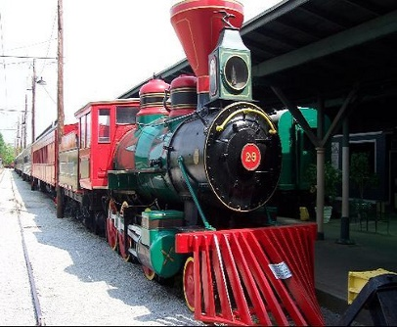
Registration- No Fee and Begins at 6:00 pm
Judging Starts at 7:00 pm

Winners for each of the following classes:
- Classic
- Modern or Daily Drive
- 4x4 or Offroad
- Motorcycle
- Street Rod
- Muscle
- Antique
Raylrode Daze Car & Truck Show

Thursday, September 27, 2018 Branchville SC

-----------------------------------------------------------------------------------------------------------------------------------
To enter mail the complete information below PO BOX 158, Branchville SC 29432 or email to carriej658@gmail.com.

Name: _________________________________________________________________________
Address: ________________________________________________________________________
City: ______________________ State: ________ Zip: ___________ Phone: _____________
Email Address: __________________________________________________________________
Car/Truck Year: ____________ Make : ______________ Model : ______________________
Signature: _______________________________________________________________________

Note registration constitutes your agreement to have any pictures of your vehicle posted on our website as well as holding the Raylrode Daze Fesitivul Inc. harmless for any damage, accidents, or injuries.

